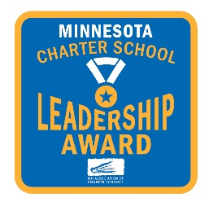
MN Association of Charter Schools
the Minnesota Charter Leader Award
AWARD INFORMATION

The MN Association of Charter School Leader Award is designed to recognize individuals who school leaders that have a demonstrated record of successful leadership of a charter school in Minnesota. The Award is given out at the Association’s Annual Innovation Convocation in May

The Award
The Minnesota Association of Charter Schools recognizes those who have demonstrated ongoing organizational and academic leadership, professionalism, innovation, and community engagement. Individuals who have gone above and beyond to “Unleash Education from Convention”.

- Eligible Individuals and Criteria

Awardees of the MN Association of Charter School Leader Award are individuals who have been in a leadership position for at least three years at their current MACS member school, and demonstrate leadership through the following:

- Empowering staff and creating a positive work environment, (20 points)
- Facilitating effective board governance, (10 points)
- Creating a culture for student achievement and success (20 points)
- Creating and supporting professional learning communities at the board and staff levels, (10 points)
- Supporting and implementing new and different programming, teaching methods, assessments or organizational procedures and practices (20 points)
- Cultivating partnerships to enhance opportunities for students or the school, and participation in the charter school community. (20 points)

- Award Process

Annually, the Association will solicit nominations for the Award.
Nominations may be submitted by:
1] The school board of the nominee’s school
2] The faculty/staff of the nominee’s school
3] The authorizer of the nominee’s school
4] An administrator within the nominee’s school
5] An administrator of another MACS member school

All applications will be reviewed by a Committee of at least 3 board members and staff of the Association.

